**Graphics and Interaction (COMP30019_2024_SM2) Game Design Document (GDD)**

**Group Name: obsidian Tutor: Antony Chacon (Fri 9:00 AM)**

Table of Contents

1. Core Concept 1

Idea 2

Player Role 2

2. Genres 2

3. Target Audience 3

4. Unique Selling Points (USPs) 3

5. Story and Narrative 4

Backstory 4

Game Progression 5

Characters 5

6. Gameplay and Mechanics 6

Player Perspective 7

Progression 8

7. Levels and World Design 9

Game World 9

Objects 9

Physics 10

8. Art and Audio 10

Art Style 10

Sound and Music 10

Game Elements 10

Assets from the Unity asset store. 10

9. User Interface (UI) 11

10. Technology and Tools 12

11. Team Communication, Timelines, and Task Assignment 12

12. Possible Challenges 13

## 1. Core Concept

### Idea

The game revolves around a disturbing, eerie Christmas night where the familiar warmth of the holiday is corrupted into a chilling experience. The player is trapped in an antique mansion after an unexpected snowstorm. During the blizzard, the power trips and the player is left in unsettling darkness. The player’s objective is to navigate countless rooms to get to the electrical switchboard, and once again illuminate the creepy building. The small source of diminishing torch light is the only thing preventing the darkness from enveloping the lonesome character.

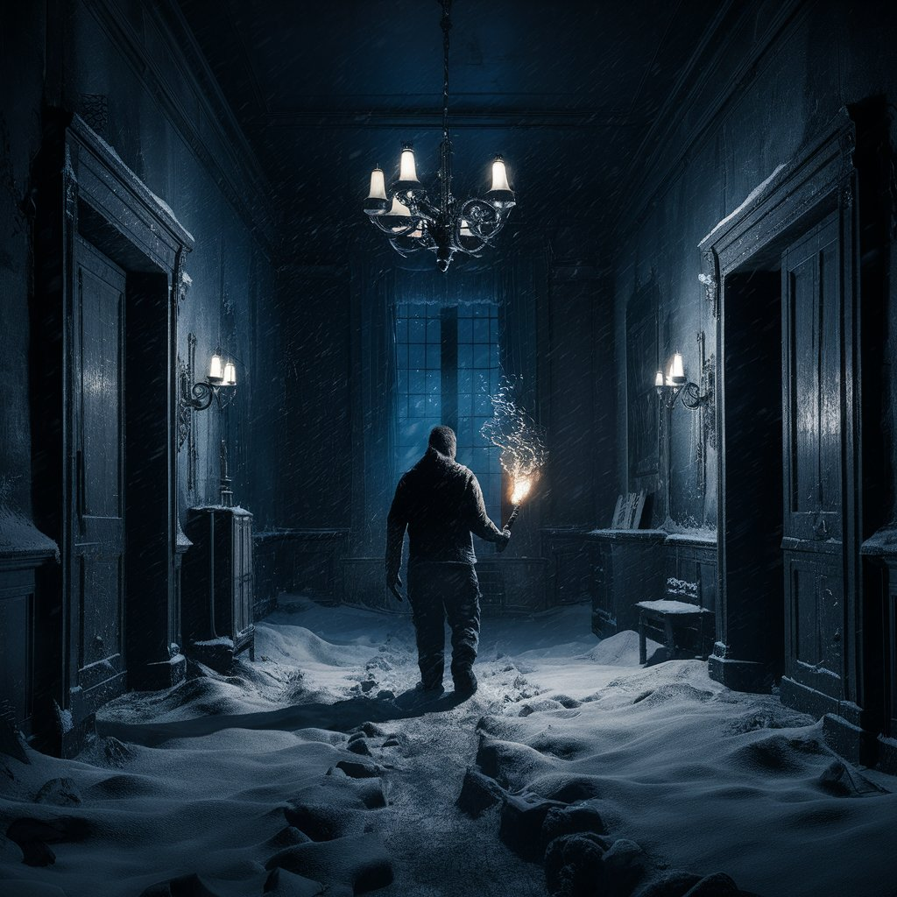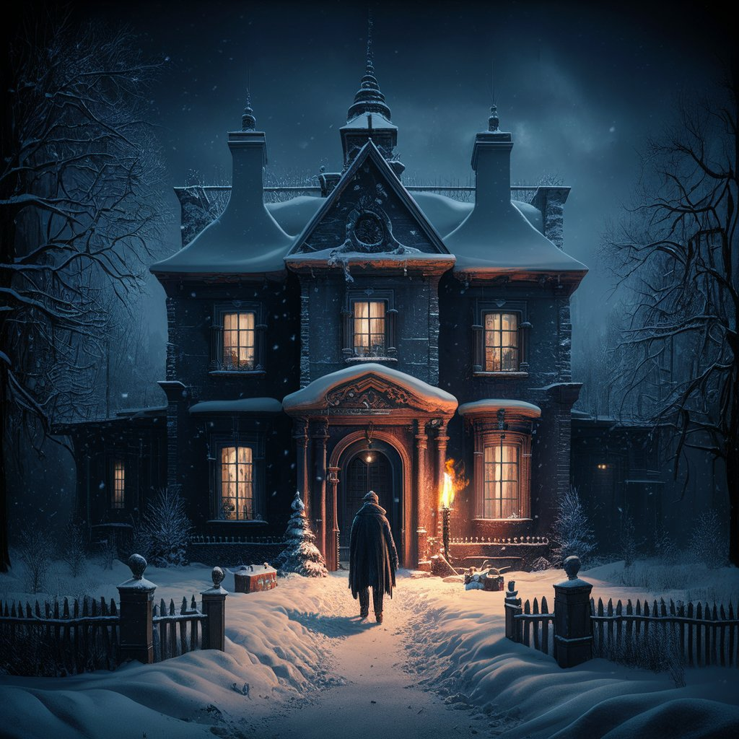{Inspirational images generated by Ideogram to convey game environment}

### Player Role

The player takes on the role of a person left alone in the holiday house. Finding a torch to begin their mission, they must seek ways to keep their light source on, and eventually reinstate the power to the building. Their mission is to find hidden objects or entities that can prolong their light source, like batteries, a lantern, a flame - all scattered across the darkened multi-story house. The objects are initially easy to uncover, however as the player progresses, elements become increasingly more camouflaged, relying on your wits and the minimal light to uncover them. While not threatened by death, the discomfort of evil lurking spirits in the haunted abode ensures a certain urgency for the player to fulfil their objective.

## 2. Genres

*Silent Night* is designed to be a typical *eerie* video game. It incorporates elements often seen in survival or horror genres, as players must avoid an unwanted fate in a disturbing environment. However, the game intentionally builds suspense through impending doom, as opposed to explicit death or horrifying characters, typical to those other genres.

It takes thematic inspiration from movies such as ‘*Home Alone’* in that it incorporates a sense of loneliness in what is usually a jolly time of year. Tim Burton’s ‘*The* *Nightmare Before Christmas’* similarly casts an eerie atmosphere over the much-adored holiday.

From a gameplay perspective, *Silent Night* plays most similarly to *‘The Long Dark’* in that it offers a first-person playing experience, and a quest to survive the darkness and the elements.

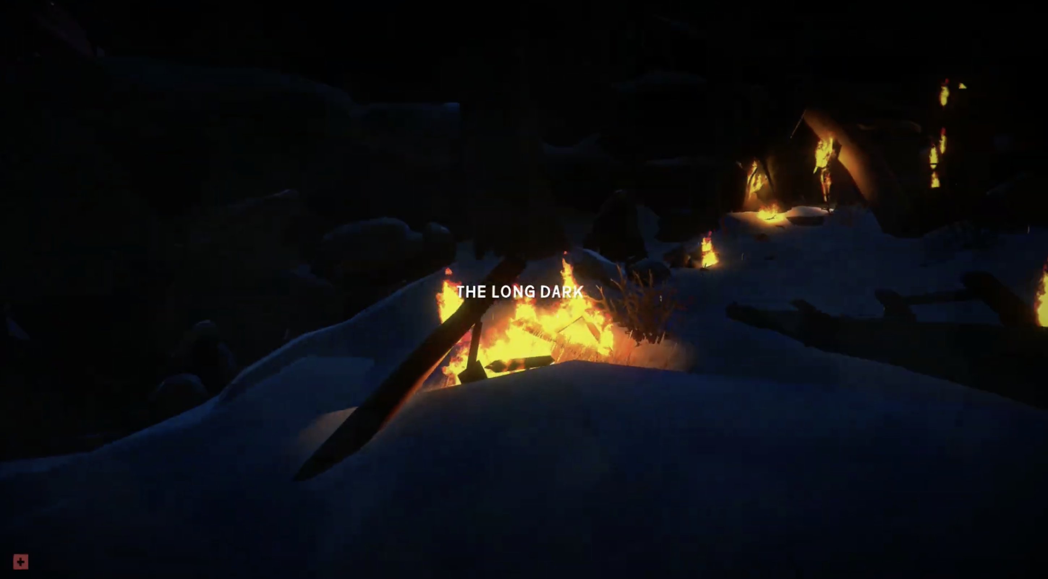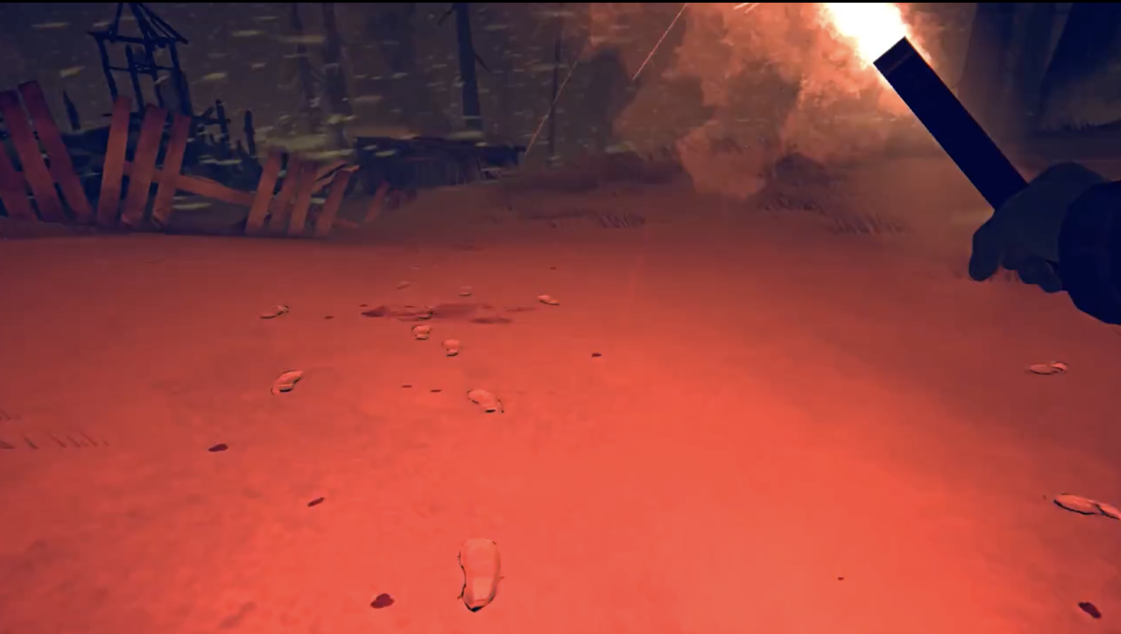

*{The Long Dark 2014 gameplay stills}*

## 3. Target Audience

This game is designed for teens and older players who enjoy a blend of puzzle-solving and adventure in their gaming experience. It appeals to both male and female gamers who appreciate a touch of eerie atmosphere without the intensity of traditional horror. Ideal for casual horror fans, the game offers a mysterious and engaging experience that focuses more on tension and exploration than on scares, making it perfect for those who enjoy challenges without the fear factor.

## 4. Unique Selling Points (USPs)

**Progressive Difficulty:**

As the game advances, objects become increasingly difficult to find, challenging players to use their wits and the limited light to uncover hidden items, creating a satisfying progression for puzzle enthusiasts.

**Dynamic Lighting Mechanics:**

The game features a unique light management system where players must find and utilize various light sources, adding a strategic layer to the gameplay as they navigate the dark mansion.

**Immersive Storytelling:**

Set against the backdrop of a snowstorm-trapped mansion, the narrative gradually unfolds as players explore, deepening their connection to the story and the mysterious environment.

**Tense Environment:**

As opposed to traditional horror games, *[Game Name]* provides a tense, eerie environment that focuses on atmosphere, creating a sense of unease without relying on jump scares or gory imagery.

## 5. Story and Narrative

### Backstory

A family of three; mum, dad and their child looking for a cozy getaway during Christmas book an Airbnb in the snowy mountains. Unbeknownst to them, the luxurious mansion they’ve chosen hides a dark secret: it’s haunted by the evil spirit of Santa Claus. As they journey towards the mansion, they notice the weather turning gloomy and unsettling, with news reports warning that heavy snowfall is on the horizon.

Upon arriving, everything seems normal except for the absence of food. So, the parents set out to go shopping, despite the terrible weather, leaving their child alone in the mansion. The child decides to explore the mansion, admiring its architecture and unique decor, and they come across a peculiar elf antique. Drawn to the strange object, they reach out to examine it but accidentally knock it over, shattering it on the floor.

In a shocking twist, the elf ornament had housed the evil spirit of Santa Claus for generations. By breaking the antique, they unknowingly unleash the spirit. However, Santa Claus can only haunt its victims in complete darkness, lurking in the shadows as it waits for the perfect moment to strike.

[When darkness falls, the mansion transforms into a twisted version of its original state. The once-familiar rooms twist into an eerie, disorienting labyrinth where nothing remains the same, and the mansion becomes a maze of endless corridors and shifting walls. Whoever’s in the house, must find a way to keep some light on, or risk falling prey to evil Santa. ]

Suddenly, a snowstorm hits, and the power trips, causing the mansion to go dark. Christmas music starts playing, and the child senses something sinister creeping up behind him. Panicked, he reaches for his phone to use the flashlight, only to find the battery nearly dead. Now, the objective is clear: navigate through the countless distorted rooms to find the electrical switchboard before the light fades completely and evil Santa claims another victim.

### Game Progression

As the player navigates the mansion, which has transformed into a maze, they must discover various objects to keep the power on, such as batteries, candles, and lanterns. As the game progresses, these objects become increasingly difficult to find and may be camouflaged within the environment. The player’s ultimate goal is to locate the switchboard and restore power to the entire mansion.

### Characters

#### Main Characters

**Protagonist/Player**

* **Background**: The protagonist is a curious and resourceful teenager with a passion for escape rooms and puzzles. From a young age, they’ve been fascinated by mysteries and always enjoyed the challenge of solving complex problems. Their analytical mind and determination make them well-suited to navigating the twisted mansion.
* **Personality:** Brave, clever, and a little bit rebellious. They’re used to figuring things out on their own and don’t easily give in to fear, even when things start to get spooky. Their curiosity sometimes leads them into risky situations, but it’s also what drives them to keep going, no matter how terrifying things become.
* **Appearance:**
* **Mission**: Navigate the maze-like mansion, find sources of light, and ultimately restore power to the mansion by locating and fixing the electrical switchboard. Along the way, they must also uncover the secrets of the mansion and the evil spirit that haunts it, all while staying one step ahead of the malevolent Santa Claus.

**Evil Santa Claus**

* **Background**: Long ago, Santa Claus was a beloved figure, spreading joy and gifts to children around the world. But one fateful Christmas Eve, he crossed paths with a powerful witch who cursed him after a misunderstanding. The curse twisted Santa's once-kind heart, turning him into a vengeful spirit. Now, he preys on those who dare to enter his domain, especially during the dark, cold winter nights when his power is strongest. Trapped inside the elf antique, his spirit lay dormant for generations, waiting for someone to set him free.
* **Personality:** Cruel
* **Appearance:** The evil Santa Claus is a twisted version of the jolly figure from holiday tales. His once bright red suit is now dark and tattered, and his face ghostly pale.
* **Mission**: To reclaim his power by haunting the mansion and its inhabitants, growing stronger with each victim he claims. His ultimate goal is to plunge the mansion into eternal darkness, trapping all souls within forever. He still carries a sack, but instead of gifts, it’s filled with terrifying, cursed objects that he uses to torment his victims.

#### Side Characters

**Creepy Elves**

* **Appearance**: Twisted versions of the familiar elves from popular Christmas fiction
* **Role**: The elves are strange, unsettling characters that spontaneously appear throughout the game. They may occasionally be helpful, offering clues to assist the player in navigating the maze.

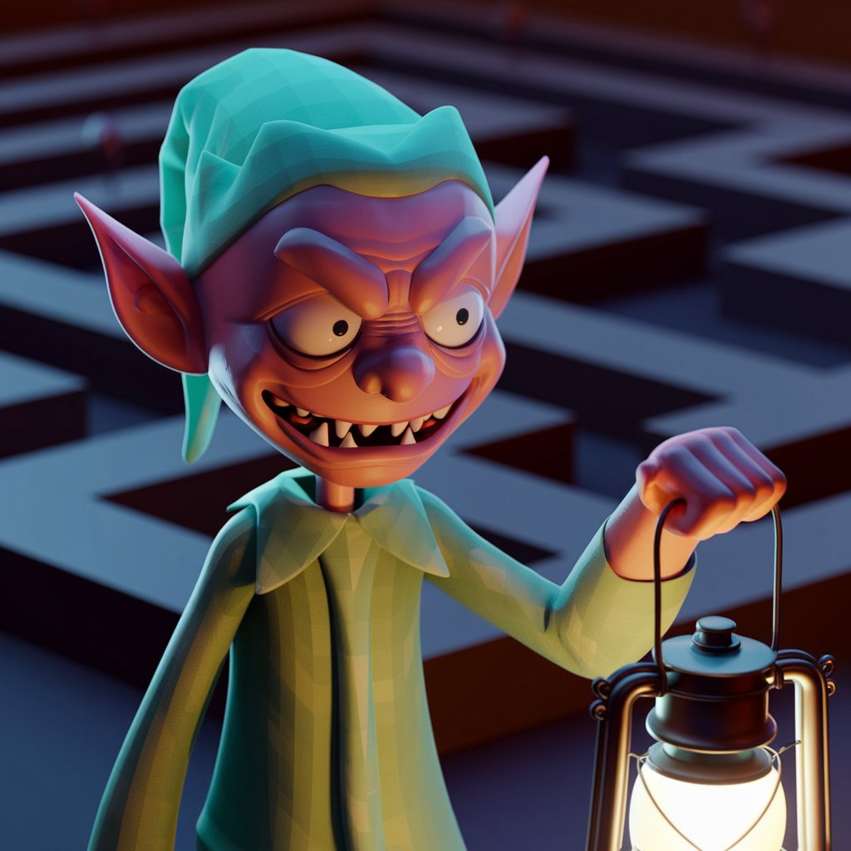

**Carol Singer Ghosts**

* **Appearance**: Ghosts dressed in Victorian-era clothing, with a slightly creepy appearance
* **Role**: They sing Christmas carols and make spooky, unsettling sounds

**Living Toys**

* **Appearance**: Popular Christmas toys like nutcrackers, jack-in-the-boxes, and dolls, all looking slightly destroyed and broken
* **Role**: These toys enhance the sinister nature of the mansion

|  |  |  |
| --- | --- | --- |
| Toy | Role | Image |
| Nutcracker |  |  |
| Jack-in-the-box |  |  |
| Dolls |  |  |

## 6. Gameplay and Mechanics

### Player Perspective

The first-person viewpoint of the game puts the player right into the spooky atmosphere of the abandoned indoor maze. The player experiences a more solitary, huge, and gloomy environment since the camera is locked to their vision and moves in tandem with their head motions. The lack of visibility for the player's character intensifies the feeling of loneliness.

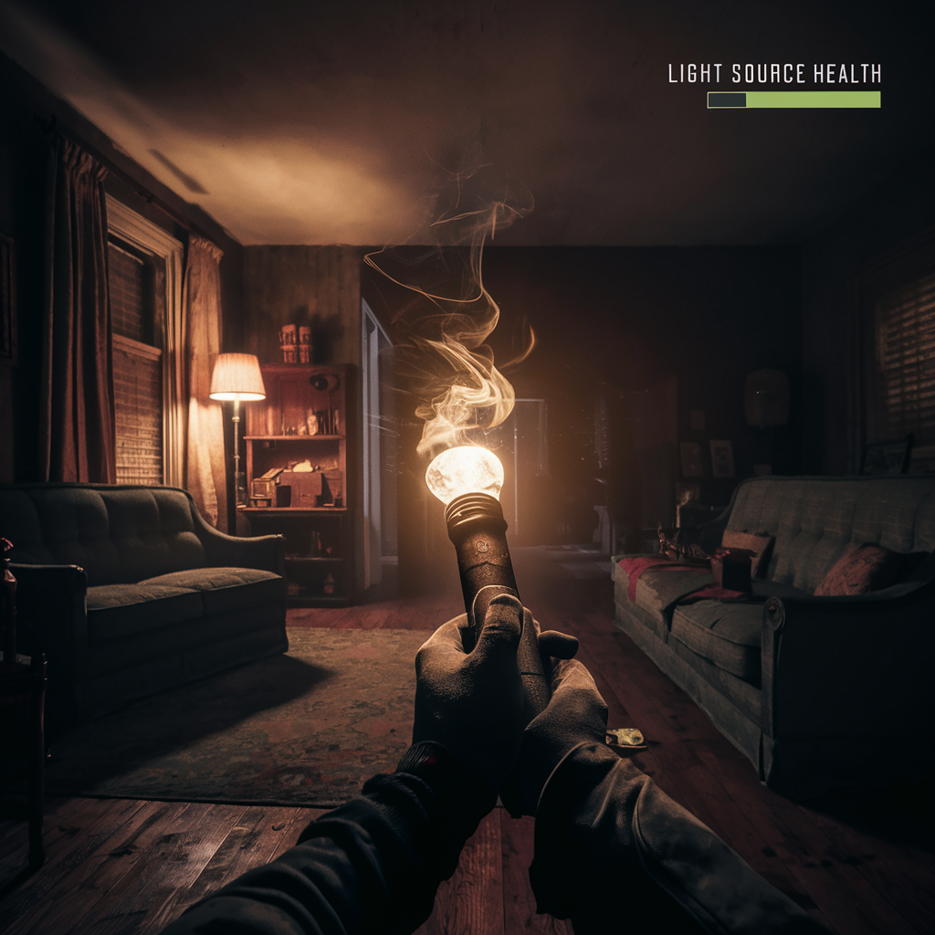

Controls

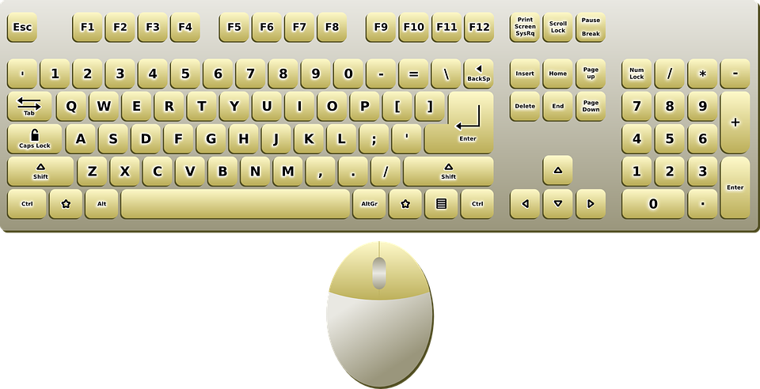

* “W”, “A”, “S” and “D” keys are used for player movement, while the mouse is used to manipulate the camera.
* “1”, “2”, “3” and “4” keys are used for items in the inventory bar.
* To interact with items or open doors, press and hold the spacebar.
* The player must carefully control the light source as it gradually runs out when they use the “F” key to turn their torch on and off.
* Tension is increased with unique controls, such as “R” for refilling the torch with batteries.
* The “E” key lets the player pick up objects that let them see farther or open doors. It takes these exchanges to go forward through the maze.

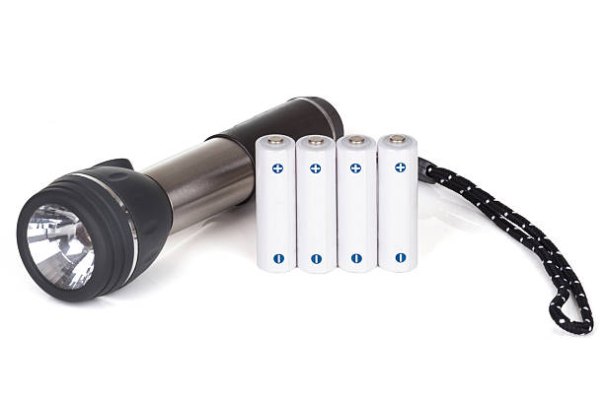

### Progression

The player explores the maze's rooms and levels at their own speed in this non-linear game. But when the torch's light wanes, the player must decide quickly where to go next. The player will face progressively difficult challenges and discover that things are either strategically placed or increasingly well-hidden as the game goes on. The urgency grows as the layout of the home gets more complicated and the light source runs out faster. The player does not "die," but the game ends if the light source disappears, leaving them in total darkness. How well the player uses their resources and how long it takes to recover power are the key indicators of success.

#### Initial Setup

At the start of the game, the player takes on the role of the protagonist who was left home alone.

The switchboard is on the 1st floor, the player starts at the basement level. The player must keep the light on while finding the key to unlock the room with the switchboard

Phase 1, Easy: Basement

Objects are easier to find

Phase 2, Medium: ground floor

Phase 3, Hard: 1st floor

Mechanics

The main gameplay is light management, where the player must continuously strike a balance between exploration and the necessity to locate light sources. There are puzzle-solving components in the game as well, where the player must figure out how to get past obstacles or open secret chambers. The psychological effects of solitude and darkness are emphasized throughout the game. The player's eyesight and hearing get increasingly distorted the longer they are in the dark, mimicking a spiral into terror. A thrilling and captivating experience is produced by the anxiety of exploring the maze with a finite amount of light, the creepy atmosphere, and the necessity to locate concealed things.

## 7. Levels and World Design

### Game World

The game is set in a three-story, three-dimensional maze with secret tunnels, halls, and connected rooms. The player can explore the whole globe, but some parts cannot be reached until they have things or have solved problems. The player is forced to rely only on memory and spatial awareness because there is no map. The player finds their way throughout the estate by going through the poorly lighted hallways, pulling open doors, and going up stairs. The setting is intended to be disorienting, with rooms that appear the same and trickery paths that might send the player in circles.

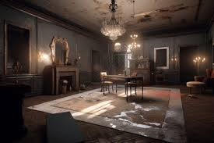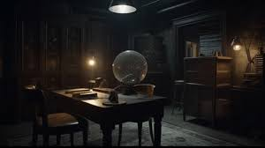

### Objects

Everyday items scattered across the maze have taken on a macabre look in the low light. Batteries, matches, and old lanterns are essential for keeping the lights on. To access other regions, you'll need other items like keys. Because they are made to fit in with their surroundings, objects are difficult to identify without close inspection. To find these vital goods, the player must make sensible use of the little light available to them. Puzzles can be solved by picking up, using, or combining objects with other things. Certain things set off certain occurrences, such as doors opening, and secret compartments being revealed.

|  |  |  |
| --- | --- | --- |
| Name | Image | Description |
| Openable drawers |  | The player may find valuable items in the openable drawer to solve the puzzle. |
| Ladders |  | The player can use the ladders to move up from basement to ground floor and the 1st floor. |
| Batteries |  | The player can press “E” to pick them up for the flashlight. |
| Light switches |  | Devices used to control the flow of electricity to a light fixture |
| Lighter and candles |  | The player should find and open the lighter to light the candles. |
| Camera |  | Some of them have night version feature. |
| Breaker box |  | It can be used to turn on power. |
| Notes |  | Notes in the game provide players with critical information, backstory, or clues that aid in unraveling the narrative or solving puzzles. |
| Mini Map |  | a small, real-time representation of the player's immediate surroundings, showing key locations, objectives |
| Compass |  | Indicates east, south, west and north |
| Keys |  | critical items that players must find and use to access restricted areas or open loot chest |
| Doors |  | interactive objects that can be opened or closed by the player to navigate between rooms and uncover hidden areas |
| Loot Chest |  | contain valuable items and resources that players can collect to enhance their abilities and progress |

### Physics

Realistic physics is used in the game, allowing items to move and fall with natural behaviour. For example, anything heavy may jam a door until it's moved, while something fragile could shatter if it falls, breaking it apart and making it useless. The player's movement mimics the character's careful investigation by being fluid yet slightly weighted. As the player navigates the dimly lit maze, the suspense is increased by the torch's beam, which flickers and sways realistically.

## 8. Art and Audio

### Art Style

The game’s art style will be low poly minimalism where the haunted mansion is composed of simple geometric shapes and flat colours. Shadows and lighting are used sparingly, creating a stark, minimalist atmosphere. The lack of detail and texture will add an eerie, dreamlike quality to the environment, making the haunted mansion feel abstract and unsettling. The low poly art style will ensure the game runs smoothly during gameplay.

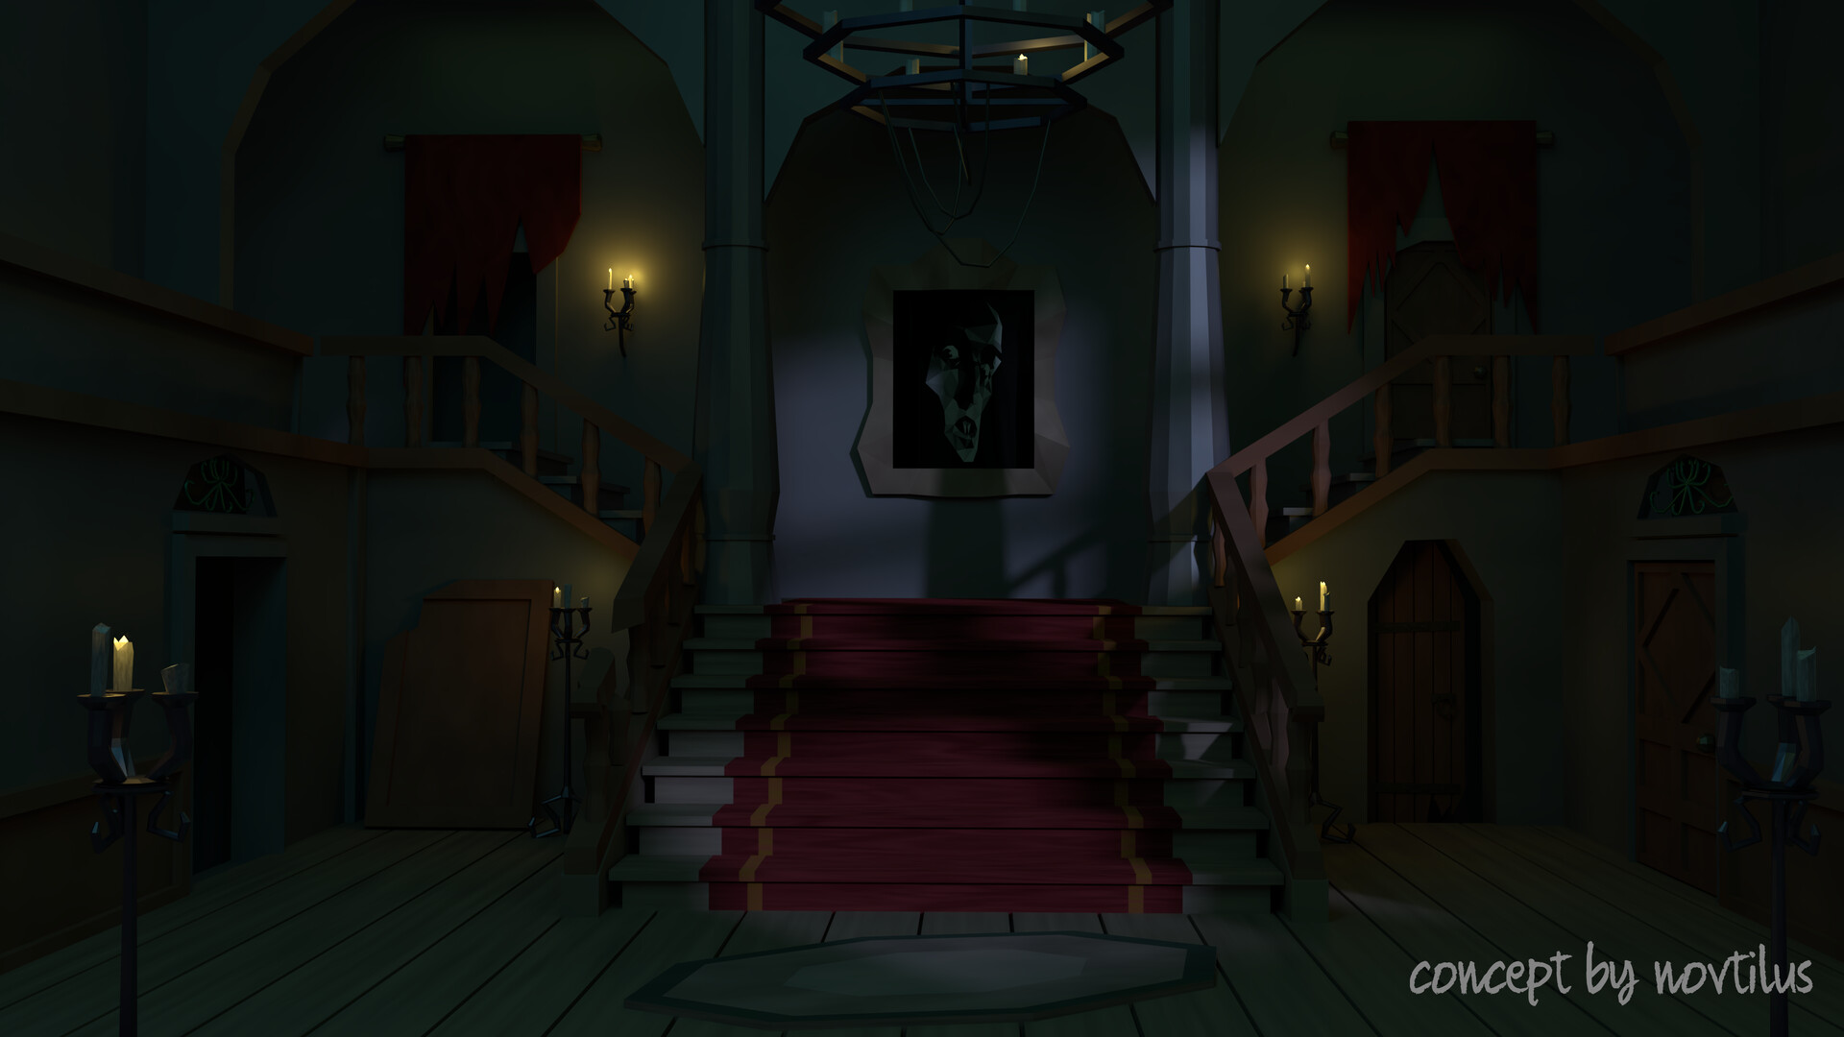

*{Inspiration: artwork by Vitalli Semenov that depicts an eerie, low poly minimalist image of a haunted mansion}*

The game will incorporate a cool toned, muted and dark colour scheme that will add to the creepiness of the haunted mansion, with the only warmth coming from the players light source and sparse light sources around.

### Sound and Music

Ambient sounds that change with the environment, with music that’s haunting and dissonant, adding to the sense of unease.

**Music:** The backing music will primarily consist of traditional Christmas carol instrumentals that create an eerie atmosphere. This is achieved through slowing down the tempo of the song and soft dynamics. Furthermore, the addition of strange instrumentation can add an unsettling effect (*Your Brain on Music: Chills & Thrills*, n.d.).

**Sound Effects:** Other sounds that can be heard while walking through the house include the players footsteps (and other’s), creaking doors and floorboards, soft jingle bells and strong winds coming from outside. Player’s interactions with objects will sound realistic e.g. Picking up a glass jar vs picking up a wooden box.

### Assets from the Unity asset store.

*Possible assets we will use in our environment, may be edited further.*

|  |  |  |
| --- | --- | --- |
| **Asset** | **Preview** | **URL** |
| Christmas and Birthday Presents Pack |  | https://assetstore.unity.com/packages/3d/props/interior/christmas-and-birthday-presents-pack-157090 |
| Retro Lamps v.1 |  | https://assetstore.unity.com/packages/3d/props/interior/retro-lamps-v-1-19601 |
| Old Low Poly Premium Furniture |  | https://assetstore.unity.com/packages/3d/environments/historic/old-lowpoly-premium-furniture-283804 |
| Low Poly Forest Pack Winter |  | https://assetstore.unity.com/packages/3d/environments/landscapes/lowpoly-forest-pack-winter-129565 |

## 9. User Interface (UI)

***Design:*** The user interface will contain minimalistic elements, as the user will need to be able to maximise their dim light source. Therefore, the user should not be hindered by large icons and interface components. There will be no ‘joystick’ or visible buttons, as the user will control everything through the controller or keyboard.

***Functionality:*** Light status will be the major functional component that players will regulate with an indicator bar. Apart from a few other smaller details, the other major visual element will be the player’s arm/s in front of them. This will be mainly to hold the light source or pick up any necessary items and game objects.

|  |  |  |
| --- | --- | --- |
| **UI Element** | **UI Preview** | **Key Design** |
| Gameplay | first player video game perspective holding a torch in a living room, with a 'light source health' bar in the top right corner | Minimalistic.  Light source health bar included. |
| Pause Menu |  | ‘Resume’ button and ‘quit’ button in the center.  Everything else is just blurred. |
| Main Menu |  | Typical main menu design |
| Lose Screen |  | Contains ‘Main Menu’ and ‘Retry’ buttons, located in the centre of the screen. |

## 10. Technology and Tools

Repository - GitHub

Game Engine - Unity Engine 2022.3 LTS

Communication - WhatsApp, Microsoft Teams

Tasks Allocation and Timeline - Microsoft Project Tasks Planner

Image AI generation tool - Ideogram

## 11. Team Communication, Timelines, and Task Assignment

To best incorporate communication, project planning, task assignment, and timelines, our group thought it best to make use of the Microsoft Teams application as a work environment. Set up to collaborate effectively, with clear instructions on its usage, the system can be primed for effective teamwork to complete the game.

*Microsoft Teams*

As a project planning tool, online meeting space, and formal project platform. It hosts a Kan-Ban board for listing, allocating and showing progress on tasks. It also hosts a discussion space where important updates can be posted for accessibility purposes.

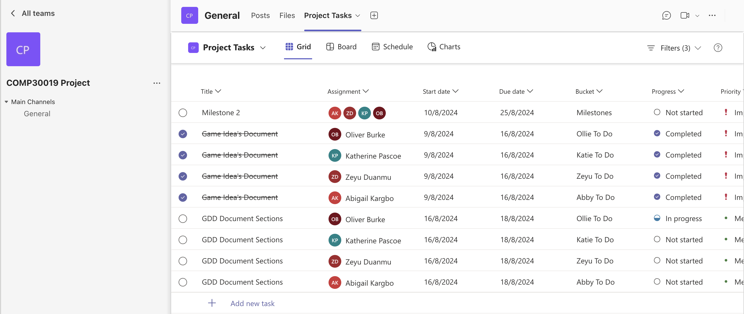

*Microsoft SharePoint* – Utilised as its natural integration in Microsoft Teams a cloud environment to version control documentation.

*WhatsApp* - For casual updates and communication, the group will employ WhatsApp. This will be utilised to send gentle reminders about meeting times, give smaller progress updates, and chat generally about direction.

**Timeline**

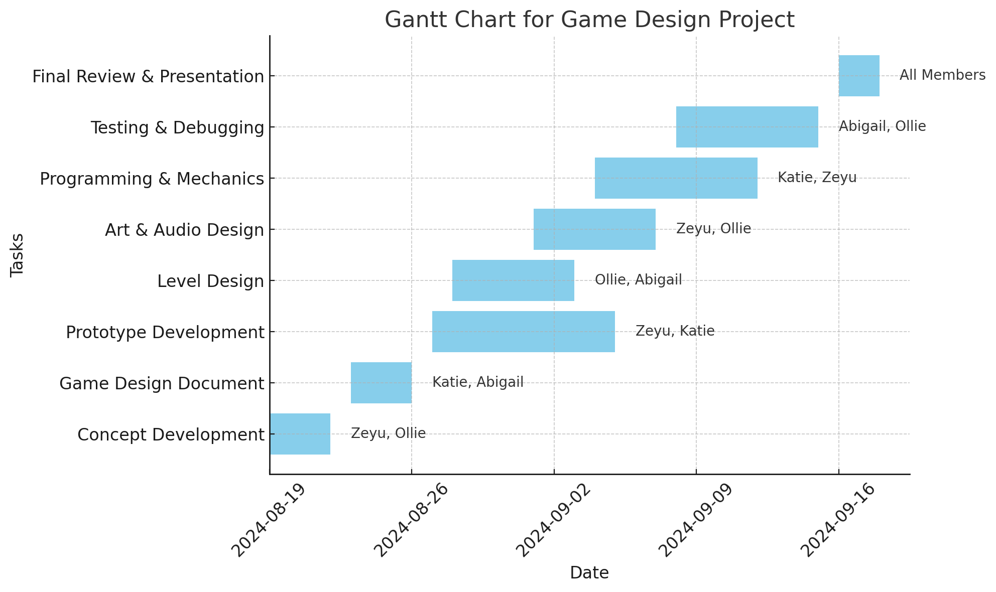

## 12. Possible Challenges

|  |  |  |
| --- | --- | --- |
| **Challenge** | **Examples** | **Resolution** |
| Poor Communication | Team members becoming unreachable.    Team members not expressing issues.    Team member's ideas not being considered. | Consistently check communication platforms such as WhatsApp and Teams regularly.    Encourage open dialogue during team meetings.    Regularly ask for input and feedback from all team members. |
| Utilising new software | Struggling to understand the software's features.    Frequent errors or bugs due to unfamiliarity.    Delays in progress as team members learn. | Make use of online documentation and resources.    Keep up to date with workshops and lectures.    Work together to solve problems. |
| Creative differences | Disagreement on the game's art style, mechanics, or game direction. | Hold brainstorming sessions in meetings to ensure team members agree.    Use voting or consensus-building techniques to resolve disputes. |
| Task distribution | Unclear assignment of responsibilities.    Some team members feeling overwhelmed, while others are underutilised. | Clearly define roles and responsibilities from the outset of the project.    Regularly review and adjust task assignments as needed. |
| Overcomplication | Adding unnecessary complexity to the game.    Difficulty in managing and integrating multiple features.    Game development becoming unmanageable. | Set clear limits on the scope of the project.    Regularly review the game's progress to keep on track.    Ensure completion of core features is prioritised. |
| Time Management | Team members missing deadlines.    Last-minute rushing to complete tasks. | Create project timeline with milestones and deadlines.    Regularly review progress and adjust schedule as needed. |

References

*Your Brain on Music: Chills & Thrills*. (n.d.). The Kennedy Center.

<https://www.kennedy-center.org/education/resources-for-educators/classroom-resources/media-and-interactives/media/music/your-brain-on-music/your-brain-on-music/your-brain-on-music-chills-and-thrills/#:~:text=Making%20Scary&text=Accelerating%20tempo%20(speed%20of%20music>

‌*Haunted Chocolatier (Unreleased) Gameplay Still*

[https://www.cbr.com/wp-content/uploads/2021/11/Haunted-Chocolatier-](https://www.cbr.com/wp-content/uploads/2021/11/Haunted-Chocolatier-Mansion-Scene.png) Mansion-Scene.png

*Vitalli Semenov – Low Poly Scary House*

[*https://vitas.artstation.com/projects/Z5xX61*](https://vitas.artstation.com/projects/Z5xX61)

*The Long Dark Gameplay Stills*

<https://image.api.playstation.com/vulcan/img/rnd/202110/1922/QE0Cyq7U5bPWbNEyFYxtAawb.jpg>

<https://encrypted-tbn0.gstatic.com/images?q=tbn:ANd9GcQwm1RWr-bawNXzZqEMJLAqk3EFATtqWy5m_g&s>